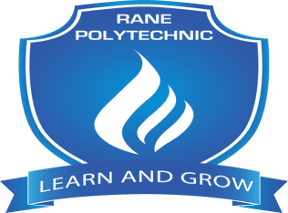

**RANE POLYTECHNIC TECHNICAL CAMPUS,TRICHY**

**DEPARTMENT OF MECHANICAL ENGINEERING**

**TRAINING AND PLACEMENT CELL**

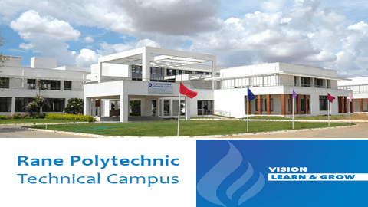

**INDUSTRIAL VISIT, IN PLANT TRAINING & INTERNSHIP**

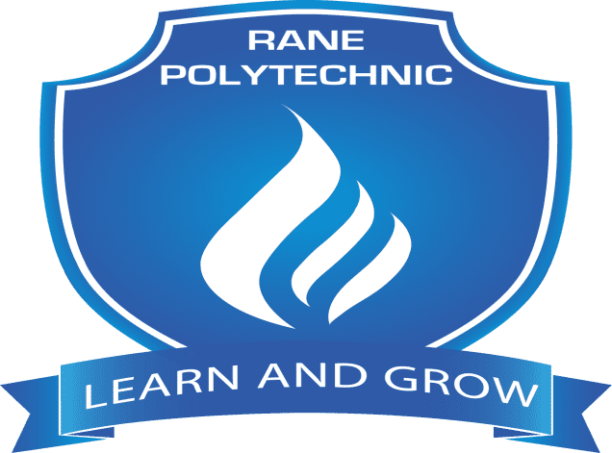

**RANE POLYTECHNIC TECHNICAL CAMPUS**

**DEPARTMENT OF MECHANICAL ENGINEERING**

**TRAINING AND PLACEMENT CELL**

**IPT & Industrial Visits & Internship**

**2019-2023**

**RANE POLYTECHNIC TECHNICAL CAMPUS**

**TRAINING AND PLACEMENT CELL**

**Activities for 2019-2022 - Industrial Visits**

|  |  |  |  |  |
| --- | --- | --- | --- | --- |
| **Date** | **Training** | **HOST Company/Institution** | **No. of Students** | **Name of the Faculty** |
| 08-06-2019 | Industrial Visit | Amman TRY, Trichy | DME-II  30 | Mr.R.Thirupathi, Lecturer,  Mr.M.Gopal, Lab instructor, |
| 20-09-2019 | Industrial Visit | Rane TRW, Viralimalai | DME-III  25 | S.Dineshkumar  Lecturer/Mechanical |
| 12-02-2020 | Industrial Visit and Tour | LMW,Coimbatore | DME-III  100 | S.Arockiasamy  C.Prasanth  Lecturer/Mechanical |
| 13-09-2021 | Industrial Visit | RBL,Trichy | DME-II  60 | R.Thiruppathi  D.Jockin  Lecturer/Mechanical |
| **Date** | **Training** | **HOST Company/Institution** | **No. of Students** | **Name of the Faculty** |
| 14-09-2021 | Industrial Visit | RBL,Trichy | DME-II  60 | R.Hariharan  Lecturer/Mechanical  S.Daniel  Technical Assistant |
| 29-09-2021 | Industrial Visit | Rane TRW,Viralimalai | DME-III  25 | C.Prasanth  Lecturer/Mechanical  Saravanakumar.P  Technical Assistant |
| 30-09-2021 | Industrial Visit | Rane TRW,Viralimalai | DME-III  25 | S.Arockiasamy  M.Arumugam  Lecturer/Mechanical |
| 25-11-2021 | Industrial Visit | REVL,Viralimalai | DME-III  25 | S.Arockiasamy  M.Arumugam  Lecturer/Mechanical |

**RANE POLYTECHNIC TECHNICAL CAMPUS**

**TRAINING AND PLACEMENT CELL**

**Activities for 2019-2020- Inplant Training**

|  |  |  |  |  |
| --- | --- | --- | --- | --- |
| **Date** | **Training** | **HOST Company/Institution** | **No. of Students** | **Name of the Faculty** |
| 25-05-2019 to 08-06-2019 | In-Plant Training | RBL,Trichy | DME-II  03 | Nil |
| 27-05-2019 to 31-05-2019 | In-Plant Training | Worth Industries, Trichy | DME-II  8 | Mr.S.Daniel, Lab Instructor |
| 29-05-2019 to 04-06-2019 | In-Plant Training | V.V.Engineering, Trichy | DME-III  6 | Nil |
| 03-06-2019 to 08-06-2019 | In-Plant Training | TATA Hitachi-Chellam Motors,Trichy | DME-II  6 | Mr. Gopal, Lab Instructor |

**RANE POLYTECHNIC TECHNICAL CAMPUS**

**TRAINING AND PLACEMENT CELL**

**Industrial Training**

**Activities for 2020-2021**

|  |  |  |  |  |
| --- | --- | --- | --- | --- |
| **Date** | **Training** | **HOST Company/Institution** | **No. of Students** | **Name of the Faculty** |
| 01/07/2020  To 17/11/2021 | Internship | ZF Rane OSD-Trichy | DME-III  27 | Nil |
| 01/06/2021  To 01/11/2021 | Internship | ZF Rane OSD-Trichy | DME-III  24 | Nil |

Our students from Mechanical have visited various Industries in and around Trichy.Our Students underwent the In-Plant Training in both RANE as well as Non RANE Companies.

Our student’s undergone one day industrial visit to Rane TRW on 20/09/2019

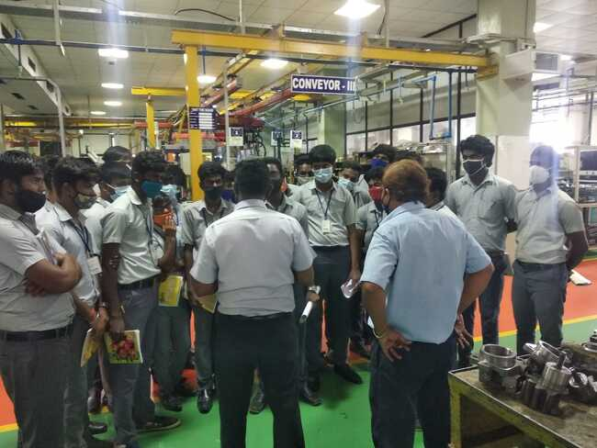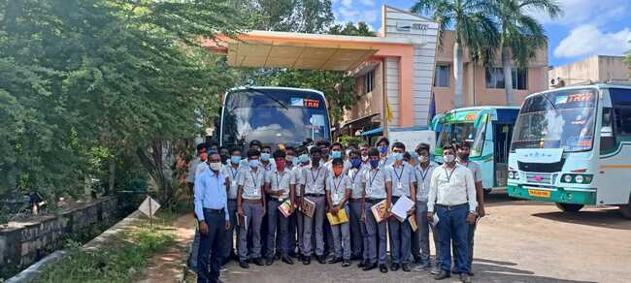

Our student’s undergone one day industrial visit to Rane TRW on 29/09/2021

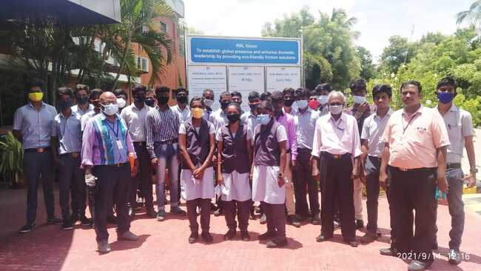

Our student’s undergone one day industrial visit to Rane RBL on 13/09/2021

Our student’s undergone one day industrial visit to Rane EVL on 25/11/2021

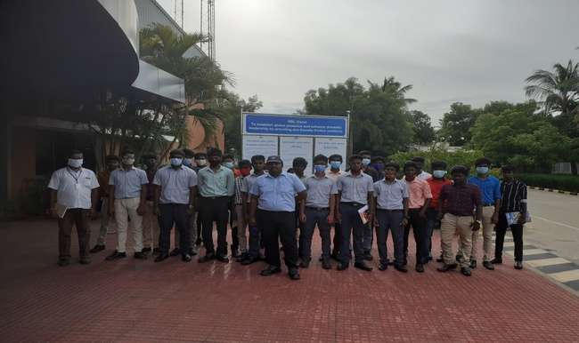

Our student’s undergone one day industrial visit to RBL on 14/09/2021

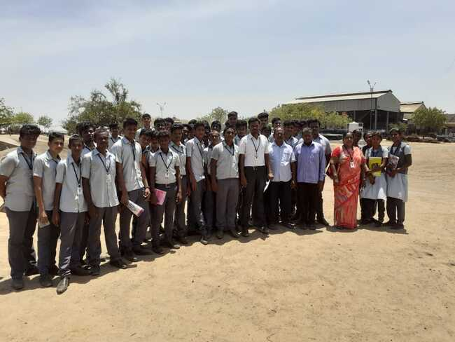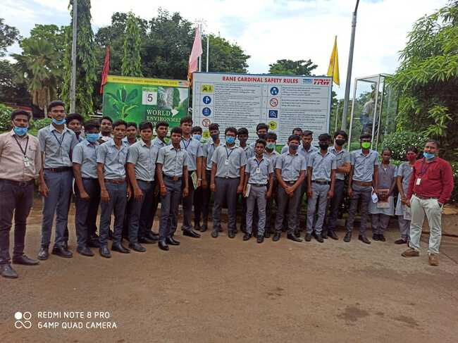

Our student’s undergone one day industrial visit to Amman TRY on 08/06/2019

25/11/2021

Our student’s undergone one day industrial visit to Rane TRW on 30/09/2021

25/11/2021

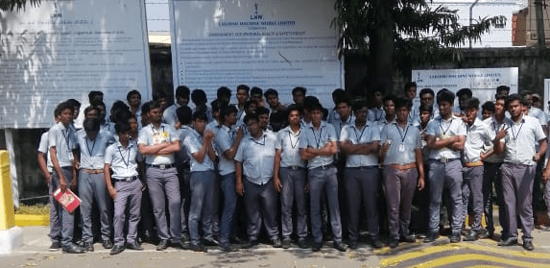

Our student’s undergone one day industrial visit to LMW and Ooty tour on 20/09/2019

25/11/2021

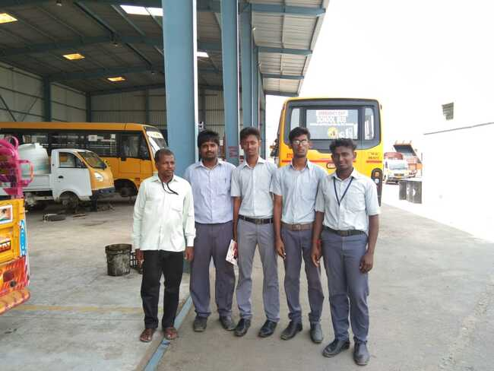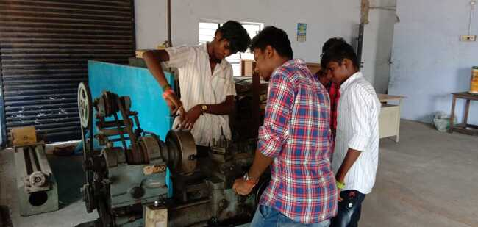

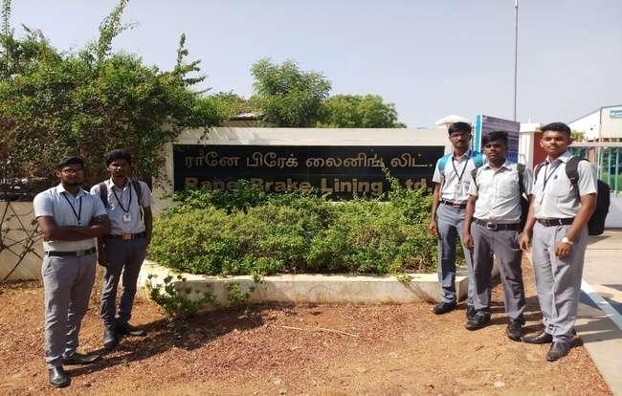

Our student’s undergone one week in plant training to Rane Brake lining,Trichy

Our student’s undergone one Week In plant training to TATA Hitachi-Chellam motors, Trichy

25/11/2021

Our student’s undergone one week in plant training to V.V Engineering, Trichy

25/11/2021

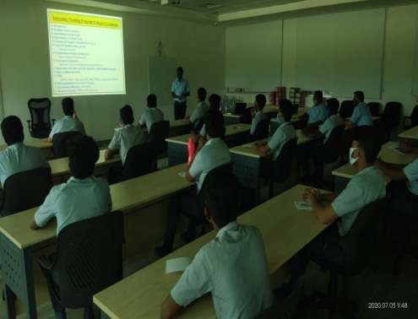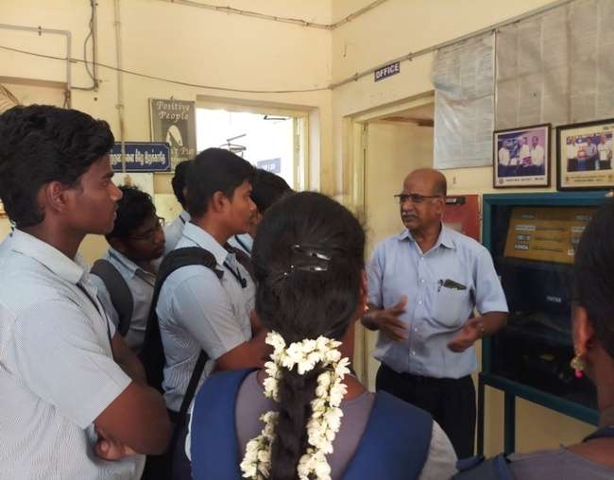

Our student’s undergone Four Month Industrial Training to Rane OSD.

Our student’s undergone one Week In plant training to worth industries.

**Our Motto** is to train the students on various industry processes and to have hands on training on the industrial instruments.

The exposure and the knowledge acquired from the industries like Manufacturing, Automobile Workshops, CNC workshops are on par with the classroom learning such as TQM, Industry Management, Quality principles, Production technology, CNC Programming and able to Operate various production machines.

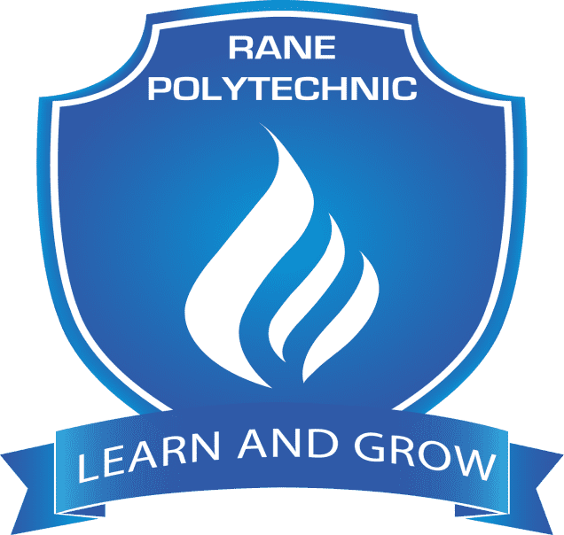

**RANE POLYTECHNIC TECHNICAL CAMPUS**

**TRAINING AND PLACEMENT CELL**

**DEPARTMENT OF MECHANICAL ENGINEERING**

**Internship & Inplant Training Details**

**2022-2023**

**RANE POLYTECHNIC TECHNICAL CAMPUS**

**TRAINING AND PLACEMENT CELL**

**Activities for 2022-2023 - Internship & Inplant Training Details**

|  |  |  |  |  |  |  |
| --- | --- | --- | --- | --- | --- | --- |
| **Sl.No** | **Name of the company** | **Date** | **No of Days** | **No of students visited** | **Name of the faculty** | |
| 1 | Rane Brake Lining,Trichy | 11/07/2022 to 20/07/2022 | 10 | DME-II  10 | Mr.T.Saravanan  Lecturer | |
| 2 | ZF Rane Automotive Private Limited,Trichy | 26/07/2022 to 02/08/2022 | 8 | DME-II  10 | Mr.S.Vadivelmurugan  Lecturer | |
| 3 | Rane Engine Valve Limited,Viralimalai | 01/08/2022 to 06/08/2022 | 6 | DME-II  10 | Mr.P.Saravanakumar  Technical Assistant | |
| 4 | Rane Brake Lining,Trichy | 30/01/2023 to 04/02/2023 | 6 | DME-III  5 | Mr.P.Dineshkumar  Senior Lecturer | |
| 5 | Worth Industries,Trichy | 30/01/2023 to 04/02/2023 | 6 | DME-III  6 | Mr.P.Saravanakumar  Technical Assistant | |
| 6 | Rane Engine Valve Limited,Viralimalai | 30/01/2023 to 04/02/2023 | 6 | DME-III  10 | Mr.S.Vinothkumar  Senior Leccturer | |
| **Sl.No** | **Name of the company** | **Date** | **No of Days** | **No of students visited** | **Name of the faculty** |
| 7 | AVM Engineering Works,Manapparai | 30/01/2023 to 04/02/2023 | 6 | DME-III  4 | Mr.Thinakaran  Technical Assistant |
| 8 | Preethi Automation Industries,Ariyamangalam | 30/01/2023 to 04/02/2023 | 6 | DME-III  7 | Nil |
| 9 | Railway Workshop,Ponmal | 30/01/2023 to 04/02/2023 | 6 | DME-III  10 | Nil |
| 10 | Brakes India,Chennai | 30/01/2023 to 11/02/2023 | 13 | DME-III  18 | Nil |
| 11 | Acoustics India Pvt.Ltd | 13/2/2023 to 18/2/2023 | 5 | DME-III  1 | Nil |
| 12 | Vythes Mobile Park | 31/1/2023 to 14/2/2023 | 15 | DME-III  2 | Nil |
| 13 | YuvanSellin CNC Industries,Viralimalai | 30/01/2023 to 04/02/2023 | 6 | DME-III  5 | Nil |

**Industrial Visit**

|  |  |  |  |  |
| --- | --- | --- | --- | --- |
| Sl.No | Name of the company | Date | No of students visited | Name of the faculty |
| 1 | WRI,BHEL | 10/09/2022 | DME-III  120 | Mr.Saravanan  C.Prasanth  Lecturer-Mecahnical |

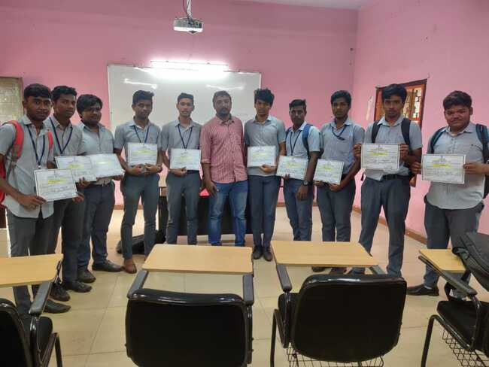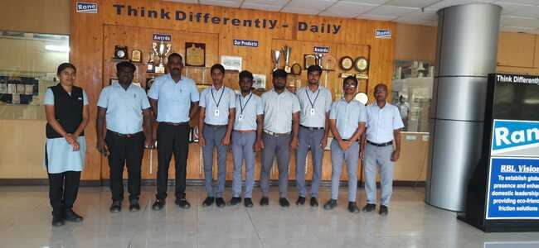

Our students undergone One week internship at Railway Workshop,Trichy

Our students undergone One week internship at Rane Brake Lining,Trichy

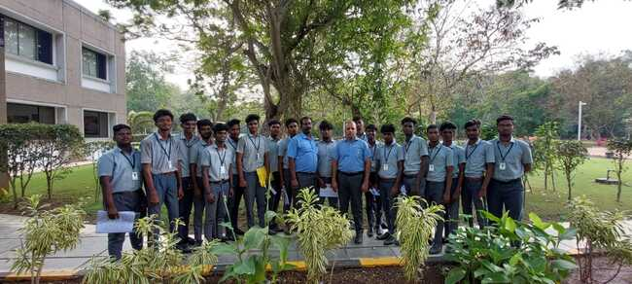

Our students undergone Two weeks internship at Brakes India,Melmaruvathur

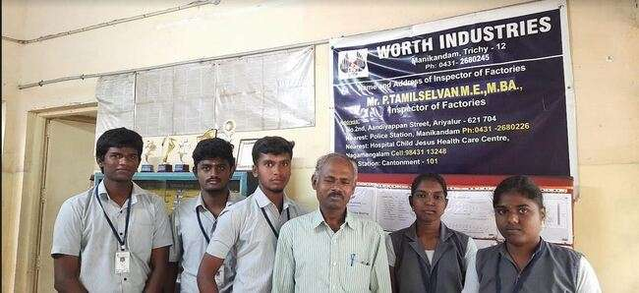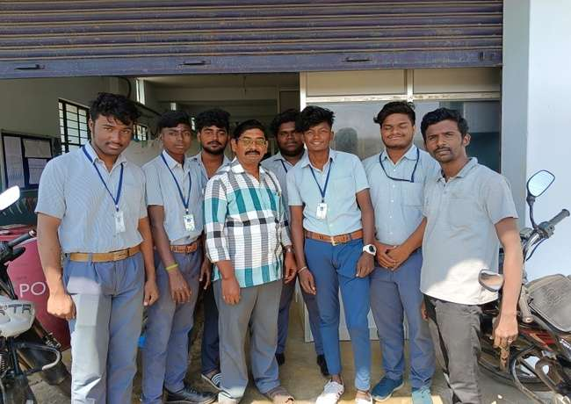

Our students undergone One week internship at Yuvan celin ,Viralimalai

Our students undergone One week internship at Worth Industries,Trichy

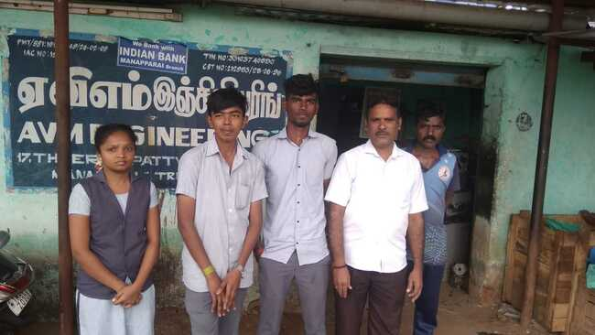

Our students undergone One week internship at AVM Engineering,Manavai

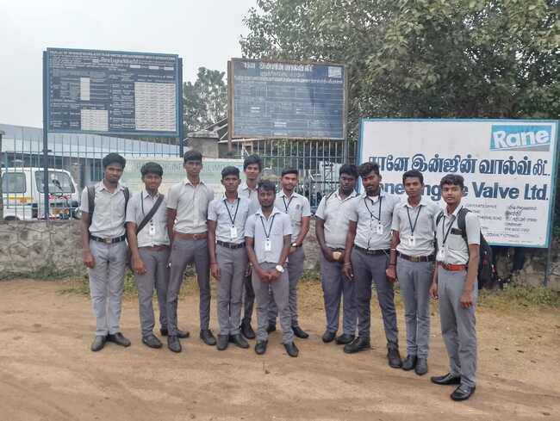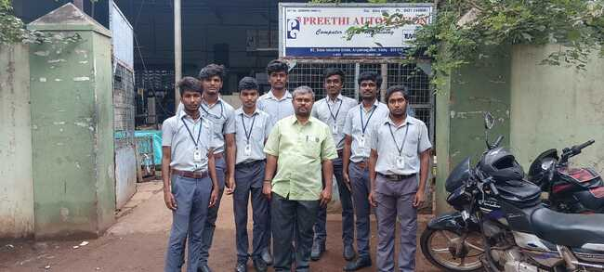

Our students undergone One week internship at Rane EVL,Viralimalai

Our students undergone One week internship at Preethi Automation,Trichy

**Our Motto** is to train the students on various industry processes and to have hands on training on the industrial instruments.

The exposure and the knowledge acquired from the industries like Manufacturing, Automobile Workshops, CNC workshops are on par with the classroom learning such as TQM, Industry Management, Quality principles, Production technology, CNC Programming and able to Operate various production machines.

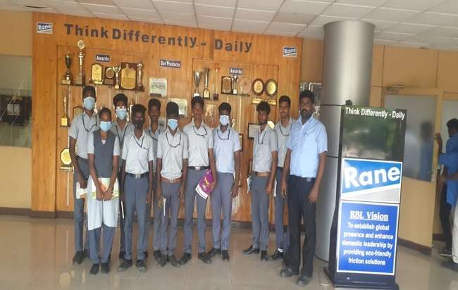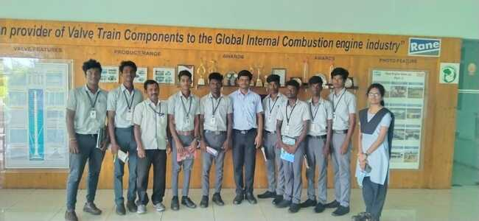

Our students undergone One week internship at Rane Brake Lining,Trichy

Our students undergone One week internship at Rane EVL,Viralimalai

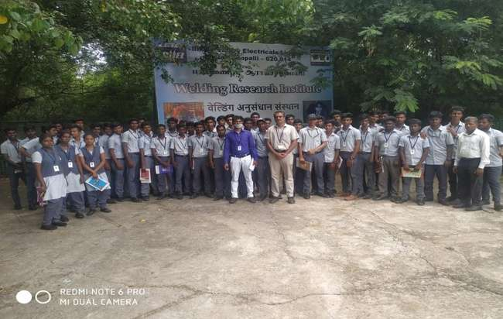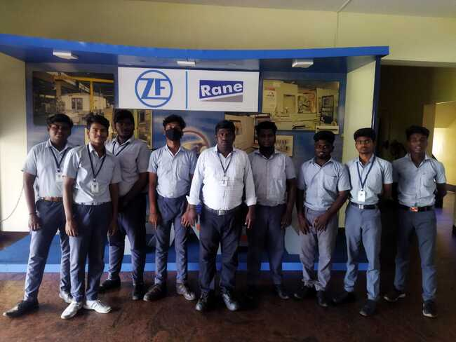

Our students undergone One Day industrial at WRI,BHEL,Trichy

Our students undergone One week internship at ZF Rane,Viralimalai

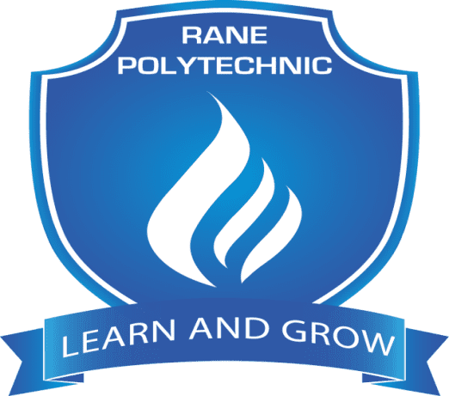

**RANE POLYTECHNIC TECHNICAL CAMPUS**

**TRAINING AND PLACEMENT CELL**

**DEPARTMENT OF MECHANICAL ENGINEERING**

**Internship & Inplant Training Details**

**2023-2024**

**RANE POLYTECHNIC TECHNICAL CAMPUS**

**TRAINING AND PLACEMENT CELL**

**Activities for 2023-2024 - Internship & Inplant Training Details**

|  |  |  |  |  |  |
| --- | --- | --- | --- | --- | --- |
| **Sl.No** | **Name of the company** | **Date** | **No of Days** | **No of students visited** | **Name of the faculty** |
| 1 | MM Forgings,Viralimalai | 07/06/2023 to 19/06/2023 | 11 | DME-III  05 | Nil |
| 2 | Rane Engine Valve Limited,Viralimalai | 12/06/2023 to 24/06/2023 | 11 | DME-III  19 | Nil |
| 3 | ZF Rane Automotive Private Limited,Trichy | 12/06/2023 to 24/06/2023 | 12 | DME-III  30 | Nil |
| 4 | Worth Industries,Trichy | 15/06/2023 to 30/06/2023 | 14 | DME-III  10 | P.Saravanakumar  Technical Assistant |
| 5 | Preethi Automation,Trichy | 20/06/2023 to 24/06/2023 | 05 | DME-III  07 | Nil |
| 6 | Rane Brake Lining,Trichy | 16/06/2023 to 28/06/2023 | 11 | DME-III  10 | Nil |

Our students from Mechanical have visited various Industries in and around Trichy.Our Students underwent the In-Plant Training in both RANE as well as Non RANE Companies.

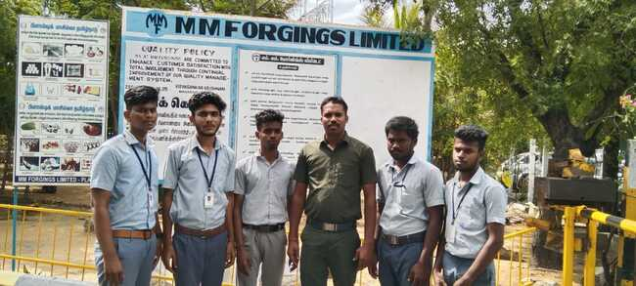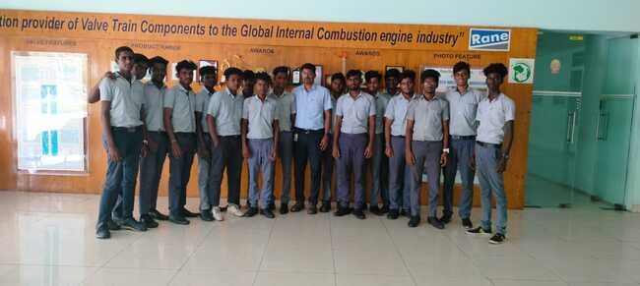

Our students undergone Two weeks internship at MM Forgings,Trichy

Our students undergone Two weeks internship at Rane Engine Valve,Trichy

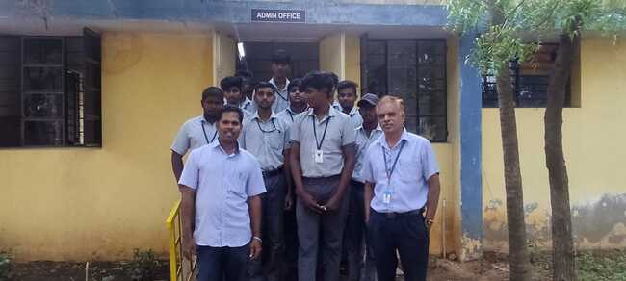

Our students undergone Two weeks internship at Worth Induatries,Trichy

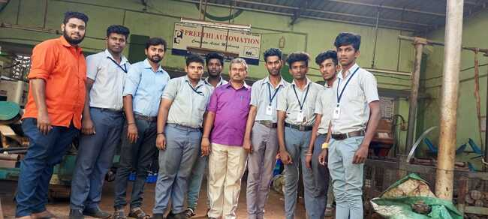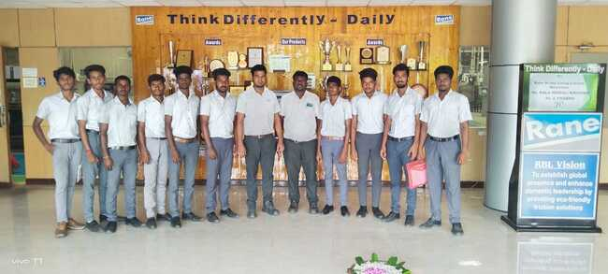

Our students undergone Two week sinternship at RBL,Trichy

Our students undergone One week internship at Preethi Automation,Trichy

**Our Motto** is to train the students on various industry processes and to have hands on training on the industrial instruments.

The exposure and the knowledge acquired from the industries like Manufacturing, Automobile Workshops, CNC workshops are on par with the classroom learning such as TQM, Industry Management, Quality principles, Production technology, CNC Programming and able to Operate various production machines.